**Monitoring/Controlling Phase**

Bryan, Fardin, Jeff, Chris

**Checkpoints Being Met**

**Group Member(s):** Bryan, Jeff, Chris

**Date of Completion:** 12/24/2017

**Scheduled Date for Completion:** 12/24/2017

**Task:** Planning of Game Requirements/Options

**Documentation/Validification (Screenshots of Work):**

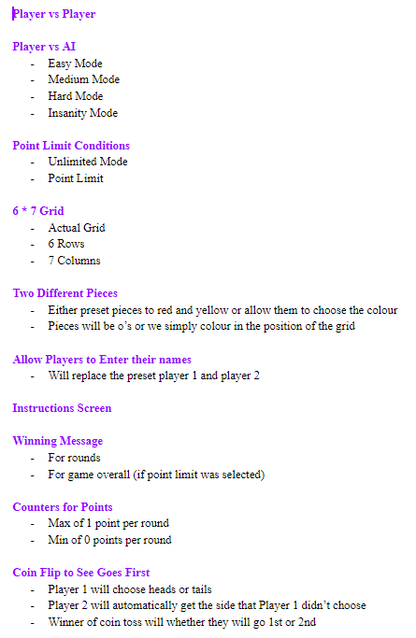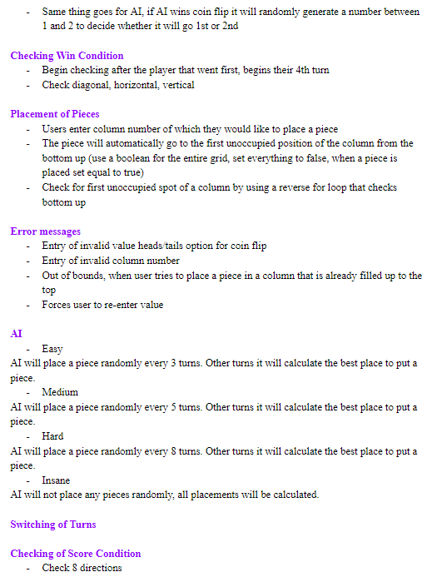

**Group Member(s):** Bryan

**Date of Completion:** 12/28/2017

**Scheduled Date for Completion:** 12/28/2017

**Task:** Coding of GUI Components (30%)

**Documentation/Validification (Screenshots of Work):**

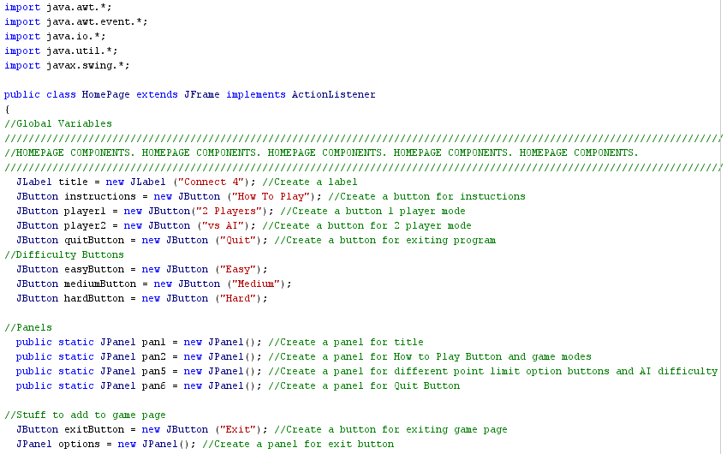

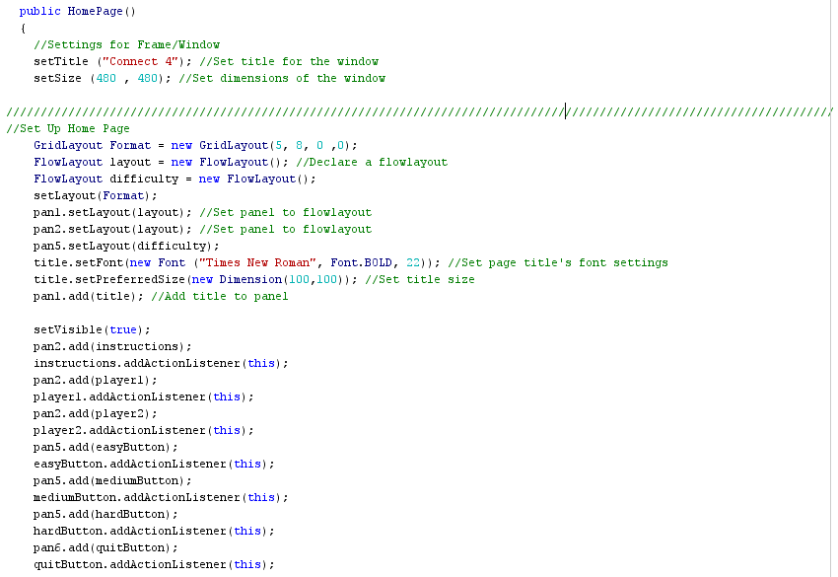

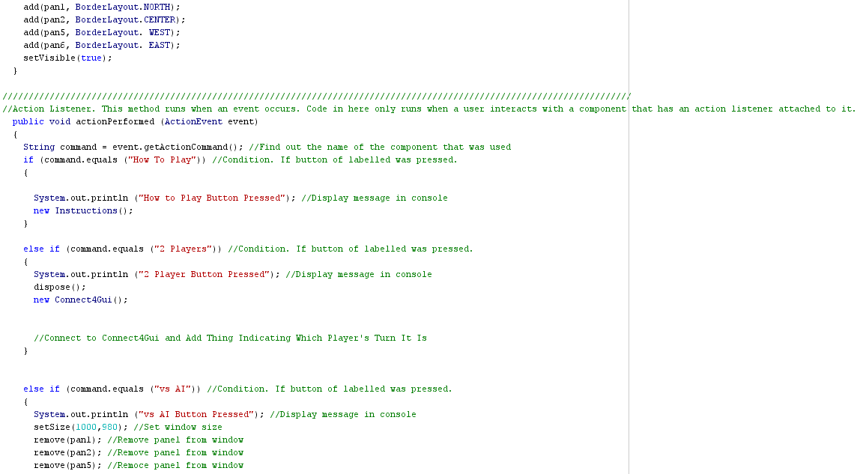

**Group Member(s):** Jeff, Fardin

**Date of Completion:** 01/02/2017

**Scheduled Date for Completion:** 01/02/2018

**Task:** Coding of Game State, Win Condition, Board (20%)

**Documentation/Validification (Screenshots of Work):**

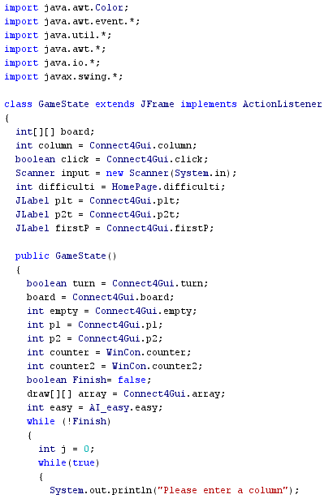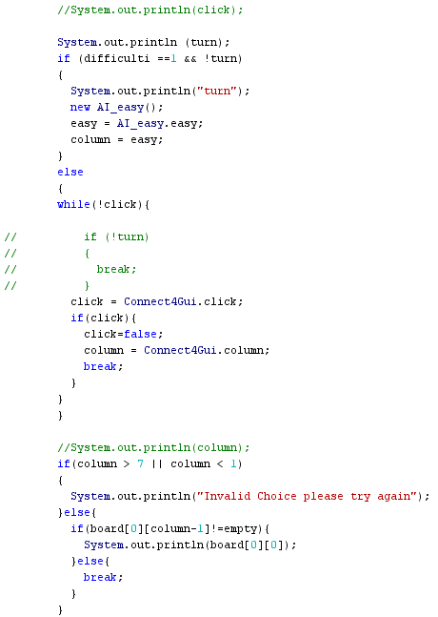

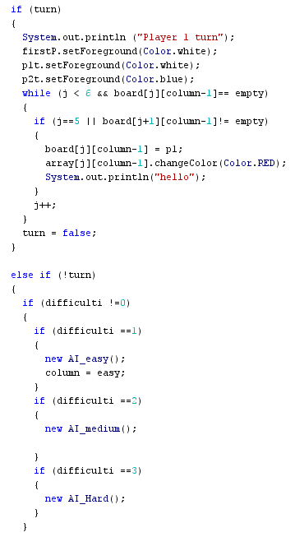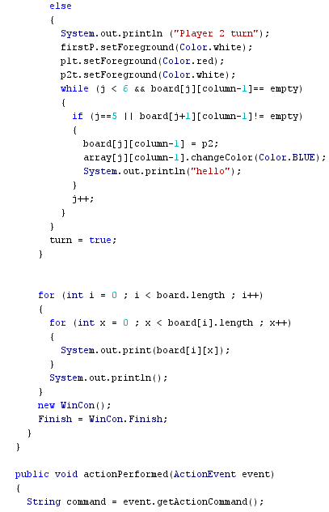

**Group Member(s):** Chris

**Date of Completion:** 01/10/2018

**Scheduled Date for Completion:** 01/10/2018

**Task:** Project Charter

**Documentation/Validification (Screenshots of Work):**

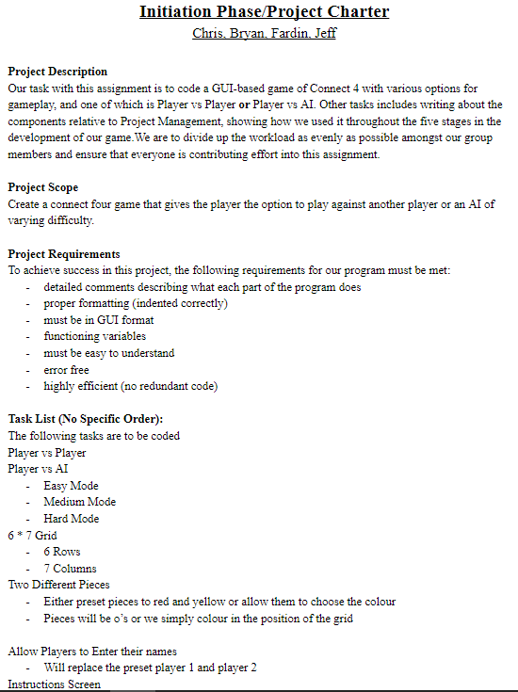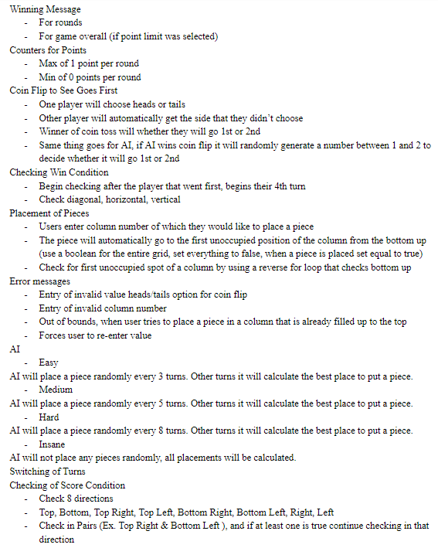

**Group Member(s):** Jeff, Fardin

**Date of Completion:** 01/12/2018

**Scheduled Date for Completion:** 01/12/2018

**Task:** Debugging of Issues Within Code

**Documentation/Validification (Screenshots of Work):** N/A

**Group Member(s):** Jeff, Fardin

**Date of Completion:** 01/11/2018

**Scheduled Date for Completion:** 01/12/2018

**Task:** Algorithm

**Documentation/Validification (Screenshots of Work):**

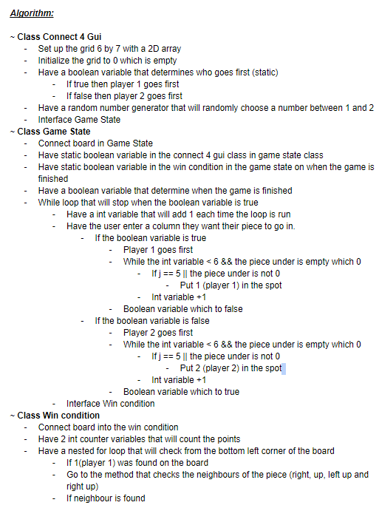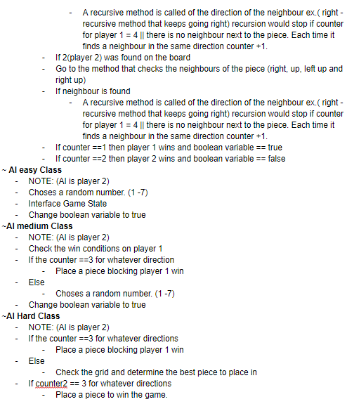

**Group Member(s):** Bryan, Chris

**Date of Completion:** 01/12/2018

**Scheduled Date for Completion:** 01/12/2018

**Task:** Planning Phase Document & Gantt Chart

**Documentation/Validification (Screenshots of Work):**

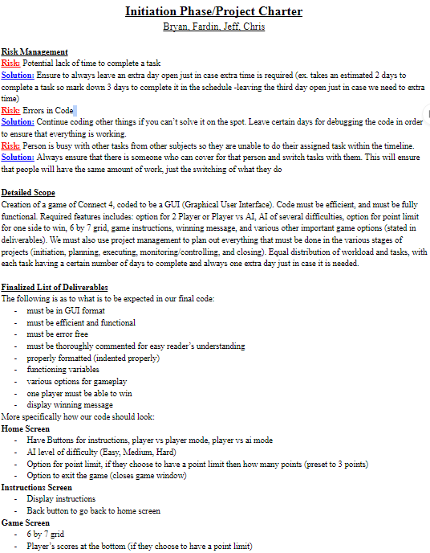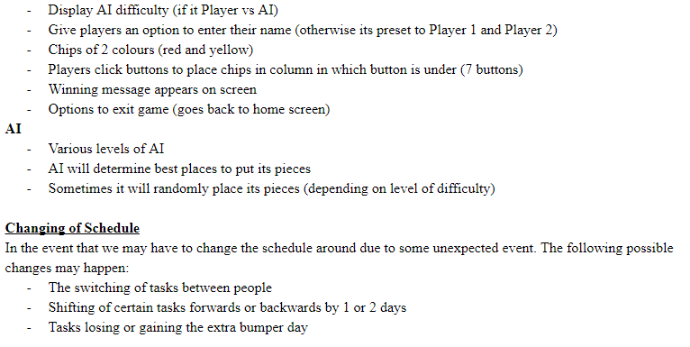

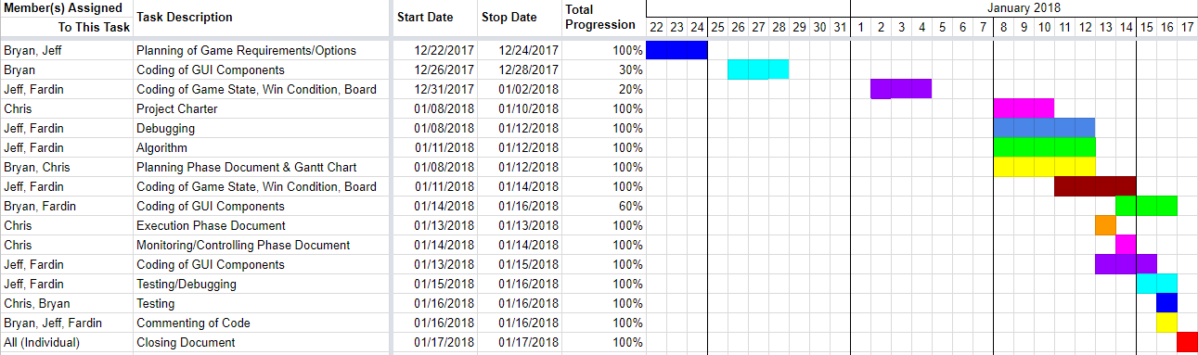

**Group Member(s):** Jeff, Fardin

**Date of Completion:** 01/18/2018

**Scheduled Date for Completion:** 01/18/2018 (Changed from 01/14/2018)

**Task:** Coding of Game State, Win Condition, Board

**Documentation/Validification (Screenshots of Work):**

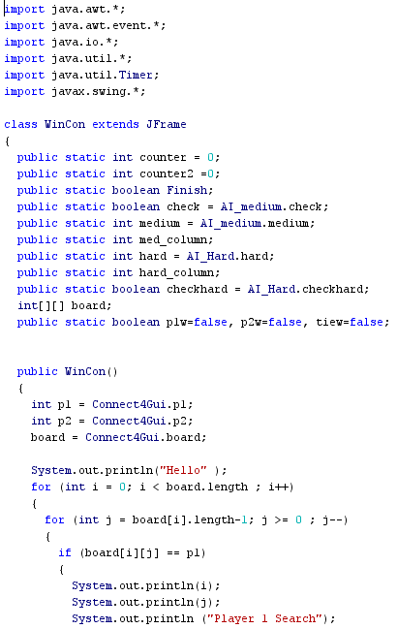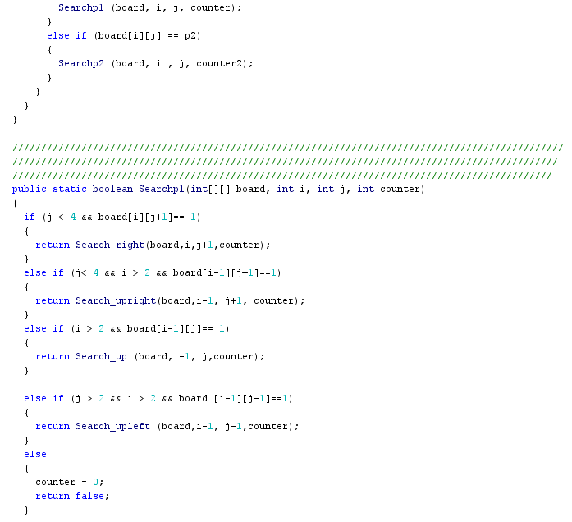**\**

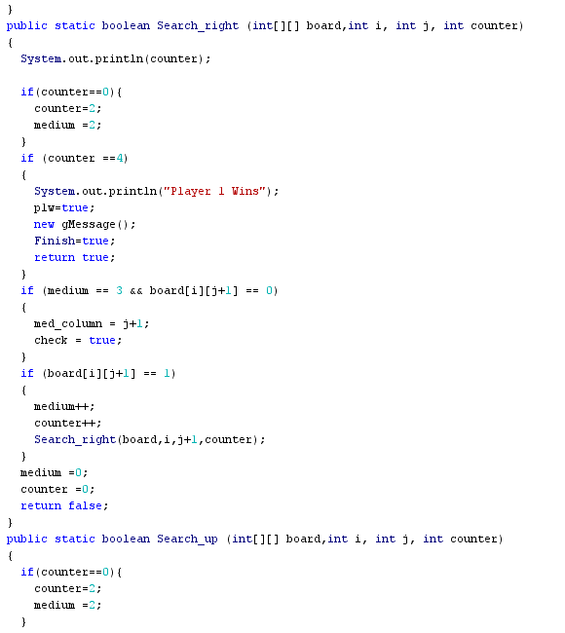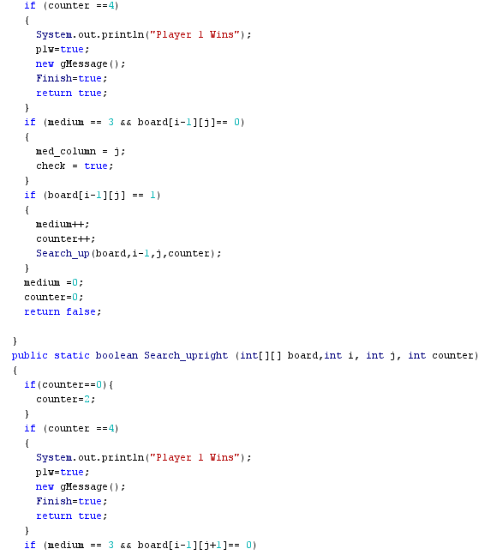

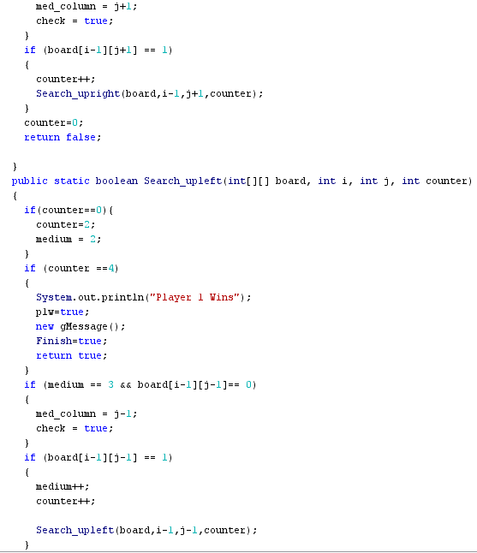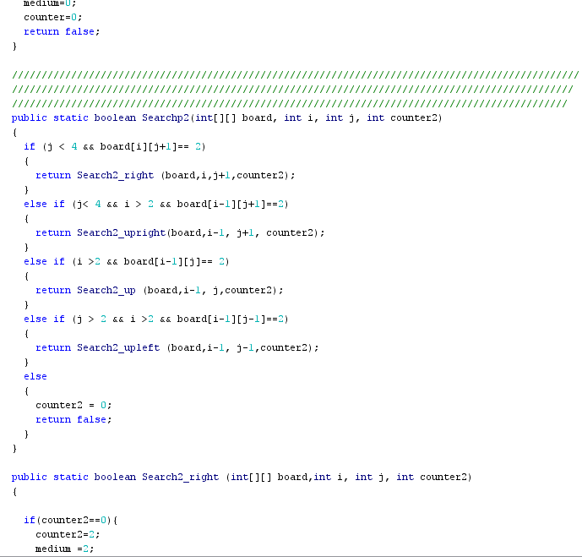

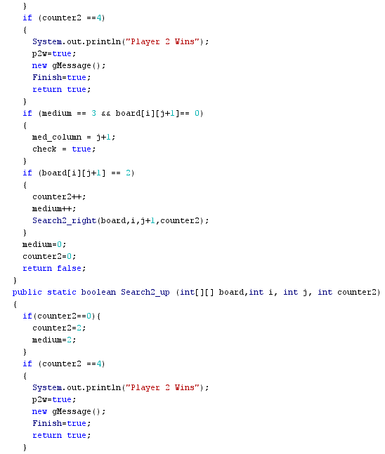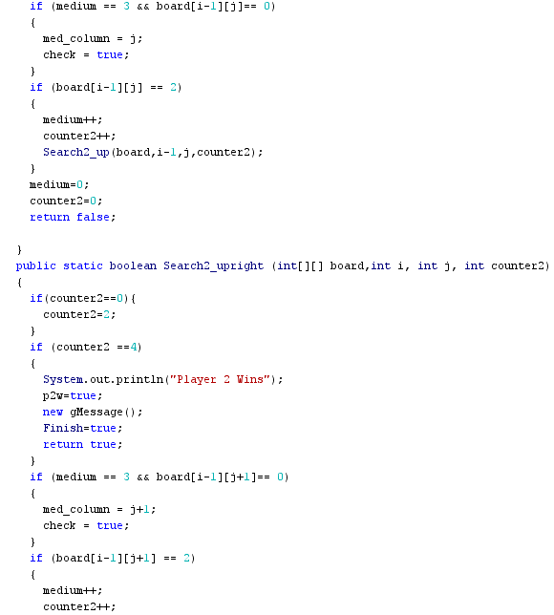

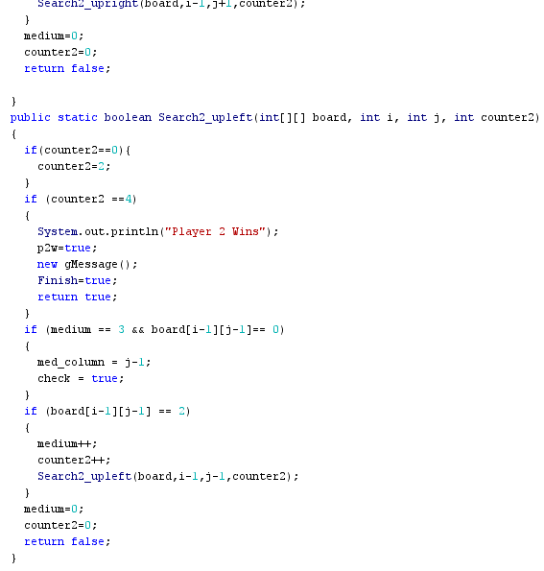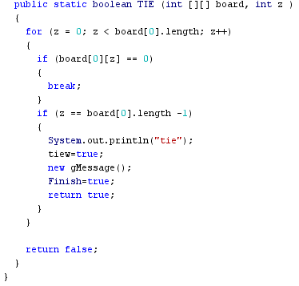

**Group Member(s):** Bryan, Fardin

**Date of Completion:** 01/17/2018

**Scheduled Date for Completion:** 01/17/2018 (Changed from 01/16/2018)

**Task:** Coding of GUI Components (60%)

**Documentation/Validification (Screenshots of Work):**

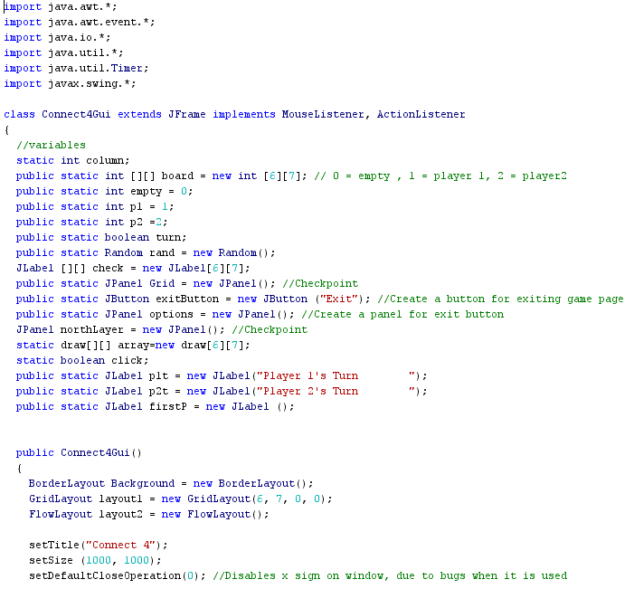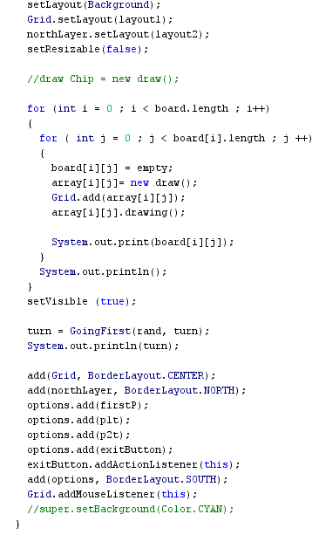

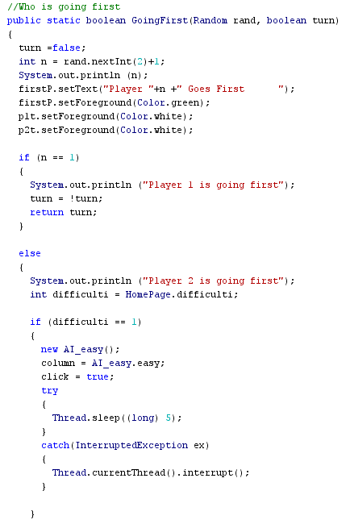

**Group Member(s):** Bryan

**Date of Completion:** N/A

**Scheduled Date for Completion:** N/A

**Task:** Execution Phase Document (Not Required, Done Through the Creation of Our Deliverable)

**Documentation/Validification (Screenshots of Work):** N/A

**Group Member(s):** Bryan, Chris

**Date of Completion:** 01/17/2018

**Scheduled Date for Completion:** 01/17/2018 (Changed from 01/14/2018)

**Task:** Monitoring/Controlling Phase Document

**Documentation/Validification (Screenshots of Work):** You’re Looking At It!!!

**Group Member(s):** Jeff, Bryan

**Date of Completion:** 01/18/2018

**Scheduled Date for Completion:** 01/18/2018 (Changed from 01/15/2018)

**Task:** Coding of GUI Components

**Documentation/Validification (Screenshots of Work):**

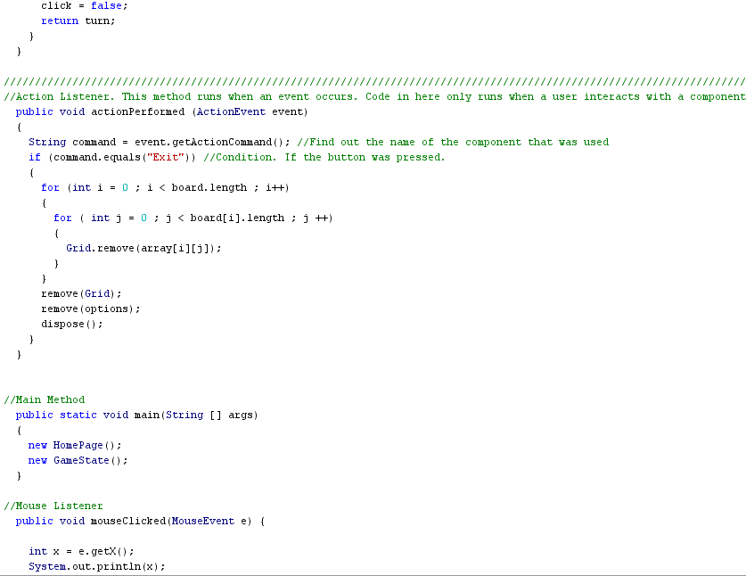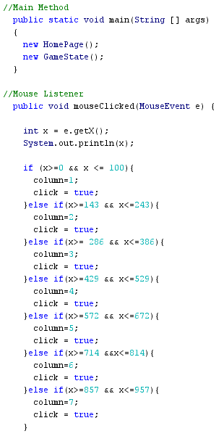

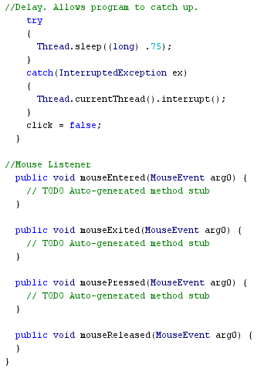

**Group Member(s):** Jeff, Fardin

**Date of Completion:** 01/19/2018

**Scheduled Date for Completion:** 01/19/2018 (Changed from 01/16/2018)

**Task:** Testing/Debugging

**Documentation/Validification (Screenshots of Work):** N/A

**Group Member(s):** Bryan, Chris

**Date of Completion:** 01/19/2018

**Scheduled Date for Completion:** 01/19/2018 (Changed from 01/16/2018)

**Task:** Testing

**Documentation/Validification (Screenshots of Work):** N/A

**Group Member(s):** Bryan, Jeff, Fardin

**Date of Completion:** 01/19/2018

**Scheduled Date for Completion:** 01/19/2018 (Changed from 01/16/2018)

**Task:** Commenting of Code

**Documentation/Validification (Screenshots of Work):** N/A

**Group Member(s):** Bryan, Jeff, Fardin, Chris (One Document Per Person; Individual)

**Date of Completion:** 01/19/2018

**Scheduled Date for Completion:** 01/19/2018 (Changed from 01/18/2018)

**Task:** Closing Document

**Documentation/Validification (Screenshots of Work):**

**Changes Made to Schedule**

**Request for Change:** Shifting of Due Dates By 2 Days (Due to Change in Amount of Time Given for Project)

**Impact Analysis:** Extra Time Allotted for All Tasks

**Approve/Deny:** Approve

**Review/Reporting:** Still on Schedule